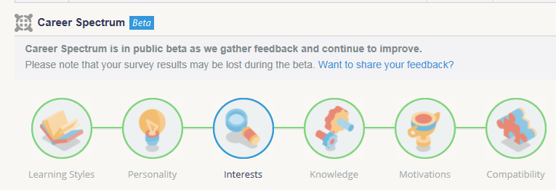
myBlueprint
Assessment Results | Relevance to me
Learning Styles

Personality

Interests

Knowledge

Motivations

Compatability

