Values to Vision

Using the checklists below:

List your top 10 values.
- _____________________  - _____________________  - _____________________  - _____________________  - _____________________ | - _____________________  - _____________________  - _____________________  - _____________________  - _____________________

List 5 Natural Gifts/Talents/Strengths.
- _____________________
- _____________________
- _____________________
- _____________________
- _____________________
List 10 positive emotions/feelings you want to experience.
- _____________________  - _____________________  - _____________________  - _____________________  - _____________________ | - _____________________  - _____________________  - _____________________  - _____________________  - _____________________

List 10 emotions you want to conquer.
- _____________________  - _____________________  - _____________________  - _____________________  - _____________________ | - _____________________  - _____________________  - _____________________  - _____________________  - _____________________

- Using the lists and examples shown below complete a “My Top 5 Values to Visions List”.
- Summarize what you learned about yourself after completing this exercise on your Unit Summary sheet.

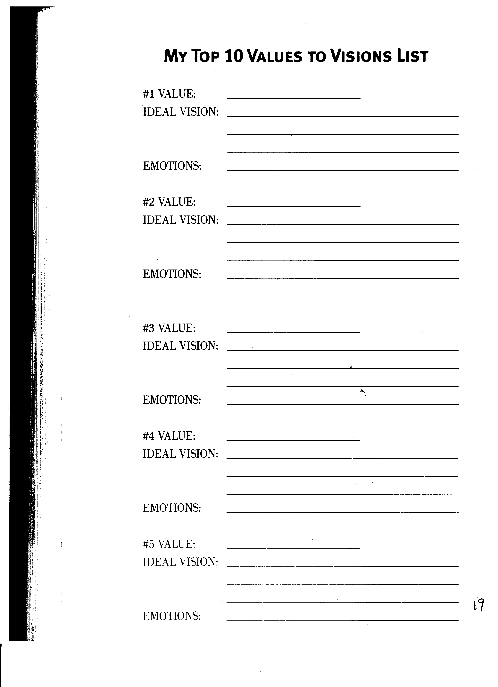
5


